Name: Jamie Anthony Brindle
Student ID: 06352322
Title: Website Development: Online Bookshop Assignment 1 Demonstration and Testing
Adding To Cart, Shopping Cart

Adding To Cart: Add book to cart from book search
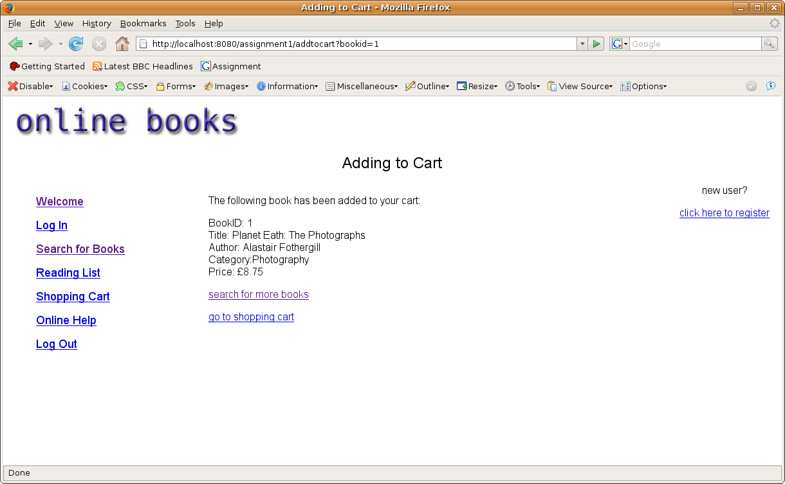
Confirmation appears, book added to session attribute, option to search more or go to cart appears

Adding To Cart: Double check book has been added to cart (not logged in)
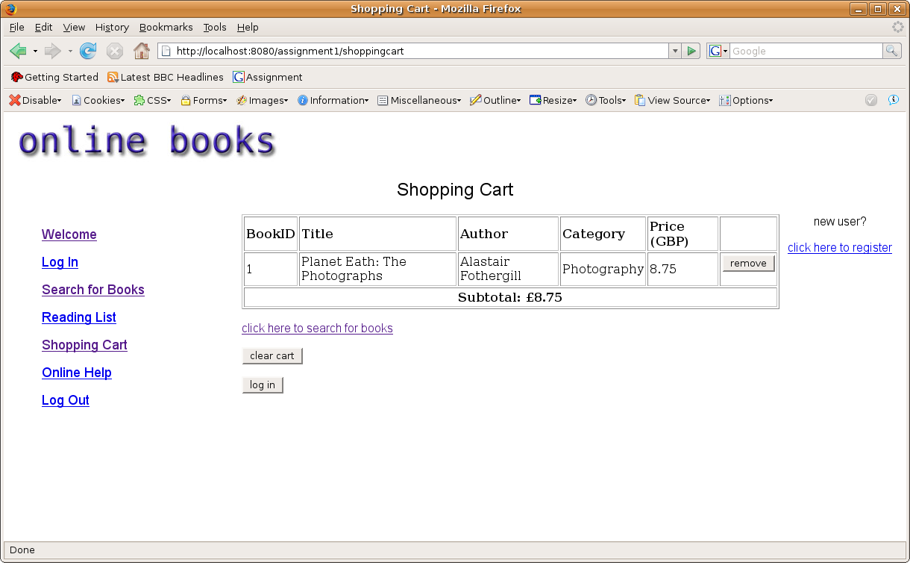
Book appears in cart as expected
Shopping Cart: (logged in)
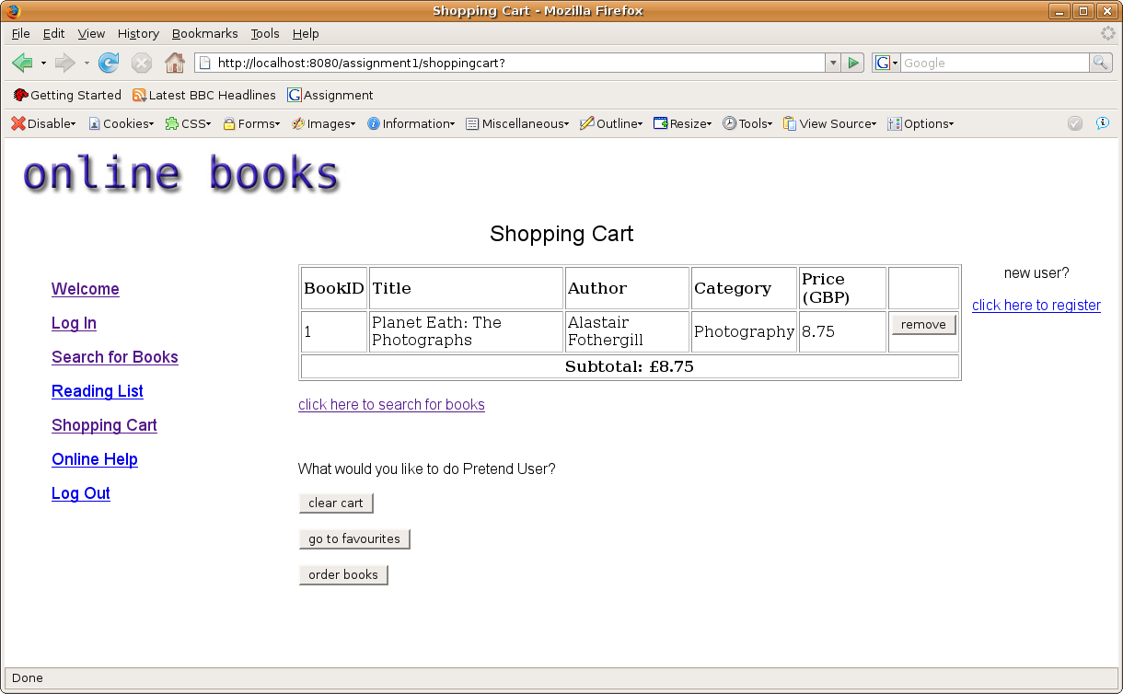
When user logged in, shopping cart greets user by name and also gives option to go to users specific favourites, or order books if books exist in shopping cart

Shopping Cart: Remove Books: Pre
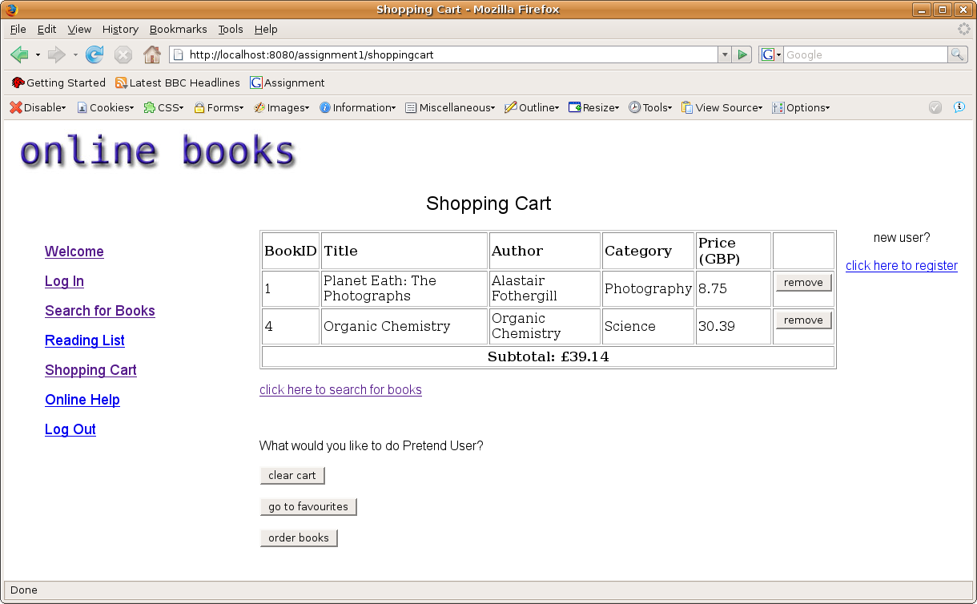
Added another book for demonstration purposes

Shopping Cart: Remove Book: Post
Book successfully removed from cart and page updated

Shopping Cart: Clear cart
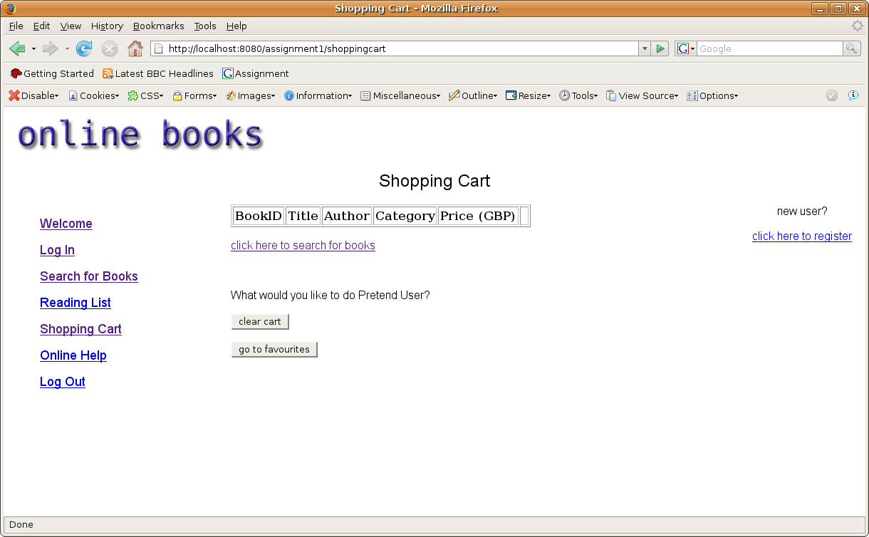
Shopping cart successfully been cleared, and 'order books' button disappeared as there is no no books to order

